***EMPLOYEE INFORMATION FORM – PLEASE FILL OUT COMPLETELY AND RETURN PROMPTLY***

***Note: All items marked with an asterisk* are REQUIRED.***

NAME*: __________________________________ NAME OF SCHOOL/CMO: ___________________________

HOME ADDRESS:_____________________________________CITY_____________________ZIP____________

PHONE: ____________________________________ CELL: _____________________________________

SEID#*:_____________________________ (10-digit State Educator Identifier Number)

DATE OF BIRTH* _____/_____/______ SOCIAL SECURITY # ______ / ______ / ___________

STAFF ASSIGNMENT CODE*: _________________________ NON CLASSROOM BASED CODE________________

EMPLOYMENT START DATE*:_____/______/_______ ASSIGNMENT START DATE*:_____/_______/_______

# OF YEARS IN THIS LEA \ SCHOOL*___________ TOTAL YEARS OF EDUCATIONAL SERVICE* _____________

HIGHEST LEVEL OF EDUCATION* – Circle One: (AA Degree, BA Degree, BA Plus 30, Master’s Degree, Master’s Plus 30, Ph.D./Ed.D, Fifth Year, Fifth Year with Induction, None)

**EMERGENCY CONTACTS:**

Name: _______________________________________Phone(s):____________________________________

Name: _______________________________________Phone(s): ____________________________________

**EMPLOYEE RACE/ETHNICITY INFORMATION:**

New federal guidelines require that we gather race/ethnicity information on all new employees in a two part question. Please complete the information listed below.

|  |  |  |  |
| --- | --- | --- | --- |
| |  | | --- | | **PART 1**  **WHAT IS YOUR ETHNICITY? (YOU MUST SELECT ONE):**  Hispanic or Latino (A person of Cuban, Mexican, Puerto Rican, South or Central American, or other Spanish culture or origin, regardless of race) **OR**  Not Hispanic or Latino |   **PART 2**  **WHAT IS YOUR RACE? (YOU MAY SELECT UP TO THREE RACIAL CATEGORIES)** | | |
| ***The above part of the question is about ethnicity, not race. No matter what you selected above,******please continue to answer the following by marking one or more boxes to indicate what you consider your race(s) to be.*** | | |
| American Indian or Alaskan Native (100) (Persons having origins in any of the original people of North, Central or South America)  Chinese (201)  Japanese (202)  Korean (203)  Vietnamese (204)  Asian Indian (205) | Laotian (206)  Cambodian (207)  Hmong (208)  Other Asian (299)  Hawaiian (301)  Guamanian (302)  Samoan (303) | Tahitian (304)  Other Pacific Islander (399)   Filipino/Filipino American (400)   African American or Black (600)   White (700) (Persons having origins in any of the original peoples of Europe, North Africa, Northwestern Asia or the Middle East) | |

**Instructions for completing the Employee Information Form**

SEID # - The SEID Number: All educators working in public K-12 California schools, charter schools and, local educational agencies in positions that require credentials from the Commission on Teacher Credentialing (CTC) are required to have statewide educator identifiers.

• The CTC assigns SEIDs to applicants for credentials based on applications to the CTC for Certificates of Clearance.

• The CTC has assigned SEIDs to all active educators in the CTC’s database.

• The SEID is a unique, 10-digit, random, system-generated, non-personally-identifiable number produced by the CTC. SEIDs are used to:

* Maintain data on individual educators over time.
* Link educator credential information with assignment information, thus aiding the monitoring of assignments and HQT statuses.

• A SEID is required for the submission of staff data to CALPADS. Any staff record without a SEID will not be accepted by CALPADS.

INSTRUCTIONS ON HOW TO OBTAIN AN EDUCATOR’S SEID NUMBER ONLINE:  
  
1. Click the following link, which will open in a new browser window: <http://www.ctc.ca.gov/credentials/cig2/cig_toc.html>

2. A box will appear asking for a user id and a password. Type the following: Username: **cig2011** Password: **ctcguide**  
  
If you do not want to input the User Name and Password each time, click the small box labeled to the left of the "Save this password in your password list" or "Remember Password". Click the "OK" button to proceed.

4.  Select SEID lookup.

5.  Enter the teacher’s Social Security #.

6. The educator’s SEID number will display. Copy that number and enter it into the form and/or directly into PowerSchool.

**School full time equivalency**:

If you have only one assignment, with only one school, simply indicate 100%. If you have assignments at multiple schools, please fill out one form for each school that you have an assignment with and the % of your time for each school.

**Staff Assignment Code**:  
Teacher (12), Administrator (10), Pupil services (11), Non-certificated Administrator (25), Charter School Non-certificated Teacher (26), Itinerant or Pull-Out/Push-In Teacher (27).

**Non-Classroom Based Code**: If your staff assignment code is a 12,25,26, or 27 leave non-classroom based code blank. If your assignment code is a 10 or 11, please find the appropriate code from the CALPADS Non Classroom Based Job Assignment code list below to describe your position and indicate this in the non-classroom based code. If you fill many different roles, enter up to 5 codes and the % of time you spend at each.

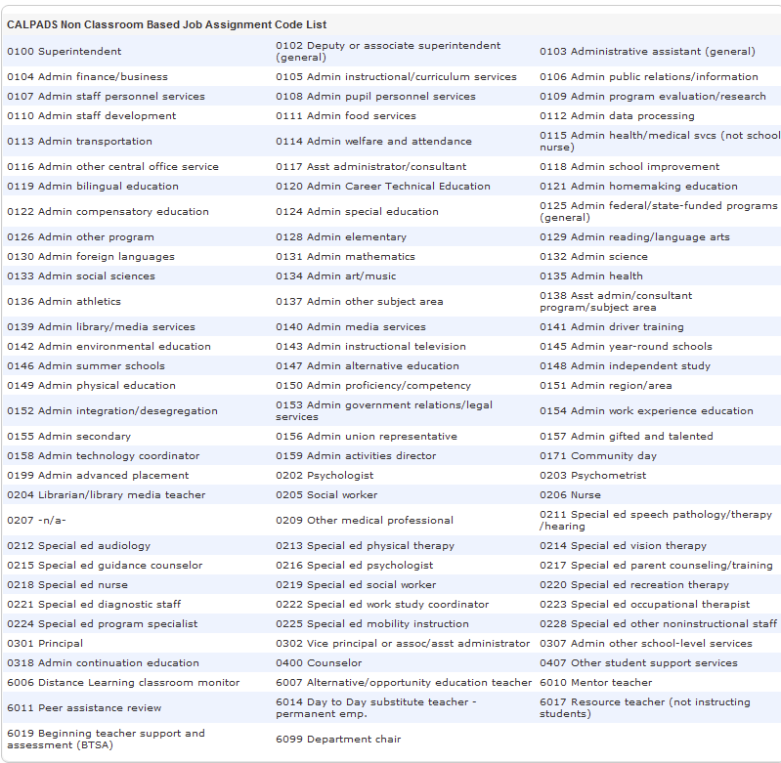

**Assignment Start Date**: The date that you began your current assignment or job function.

**Employment Start Date**: The date you began employment within your current organization (e.g. school district or CMO) - typically matches the assignment start date unless your role changed. This date must match or come before any assignment start dates.

**# Of Years in this LEA \ School** - If less than 1, indicate 1.

There are three categories of teaching or administrative staff that do not require credentials; therefore, staff in any of these categories (listed in the table below) may not in fact possess SEIDs, but they are encouraged to request SEIDs, as noted below.

**Non-certificated Administrator**   
Data related to **non-certificated administrators at the levels of assistant, deputy, associate superintendent, or higher** have been reported to CBEDS in the past. If these do not have SEIDs, data related to these staff will not be maintained in CALPADS and will not be part of the LEAs’ official staff counts. Non-certificated administrators may receive SEIDs from the CTC by requesting Certificates of Clearance. Once they have SEIDs, these staff will be included in the LEAs’ official data.

**Non-certificated Other**Data related to occupational therapists and psychometrists have been reported to CBEDS in the past. If these staff do not have SEIDs, data related to these staff will not be maintained in CALPADS. These “other” on-certificated staff may receive SEIDs from the CTC by requesting Certificates of Clearance. Once they have SEIDs, these staff will be included in the LEAs’ official data.

**Charter School Non-certificated Teacher or Administrator**Data related to **charter school non-certificated teachers who are teaching non-core courses—as well as charter school non- certificated administrators—who do not have SEIDs** will not be maintained in CALPADS and will not be part of the LEAs’ official teacher counts. Charter school non-certificated teachers or administrators may receive SEIDs from the CTC by requesting Certificates of Clearance. Once they have SEIDs, these staff will be included in the LEAs’ official data.

NOTE: In order to capture course completion data for students who are taking courses from charter school non-certificated teachers, LEAs may submit—in the course section file, for such teachers without SEIDs—a “9999999999